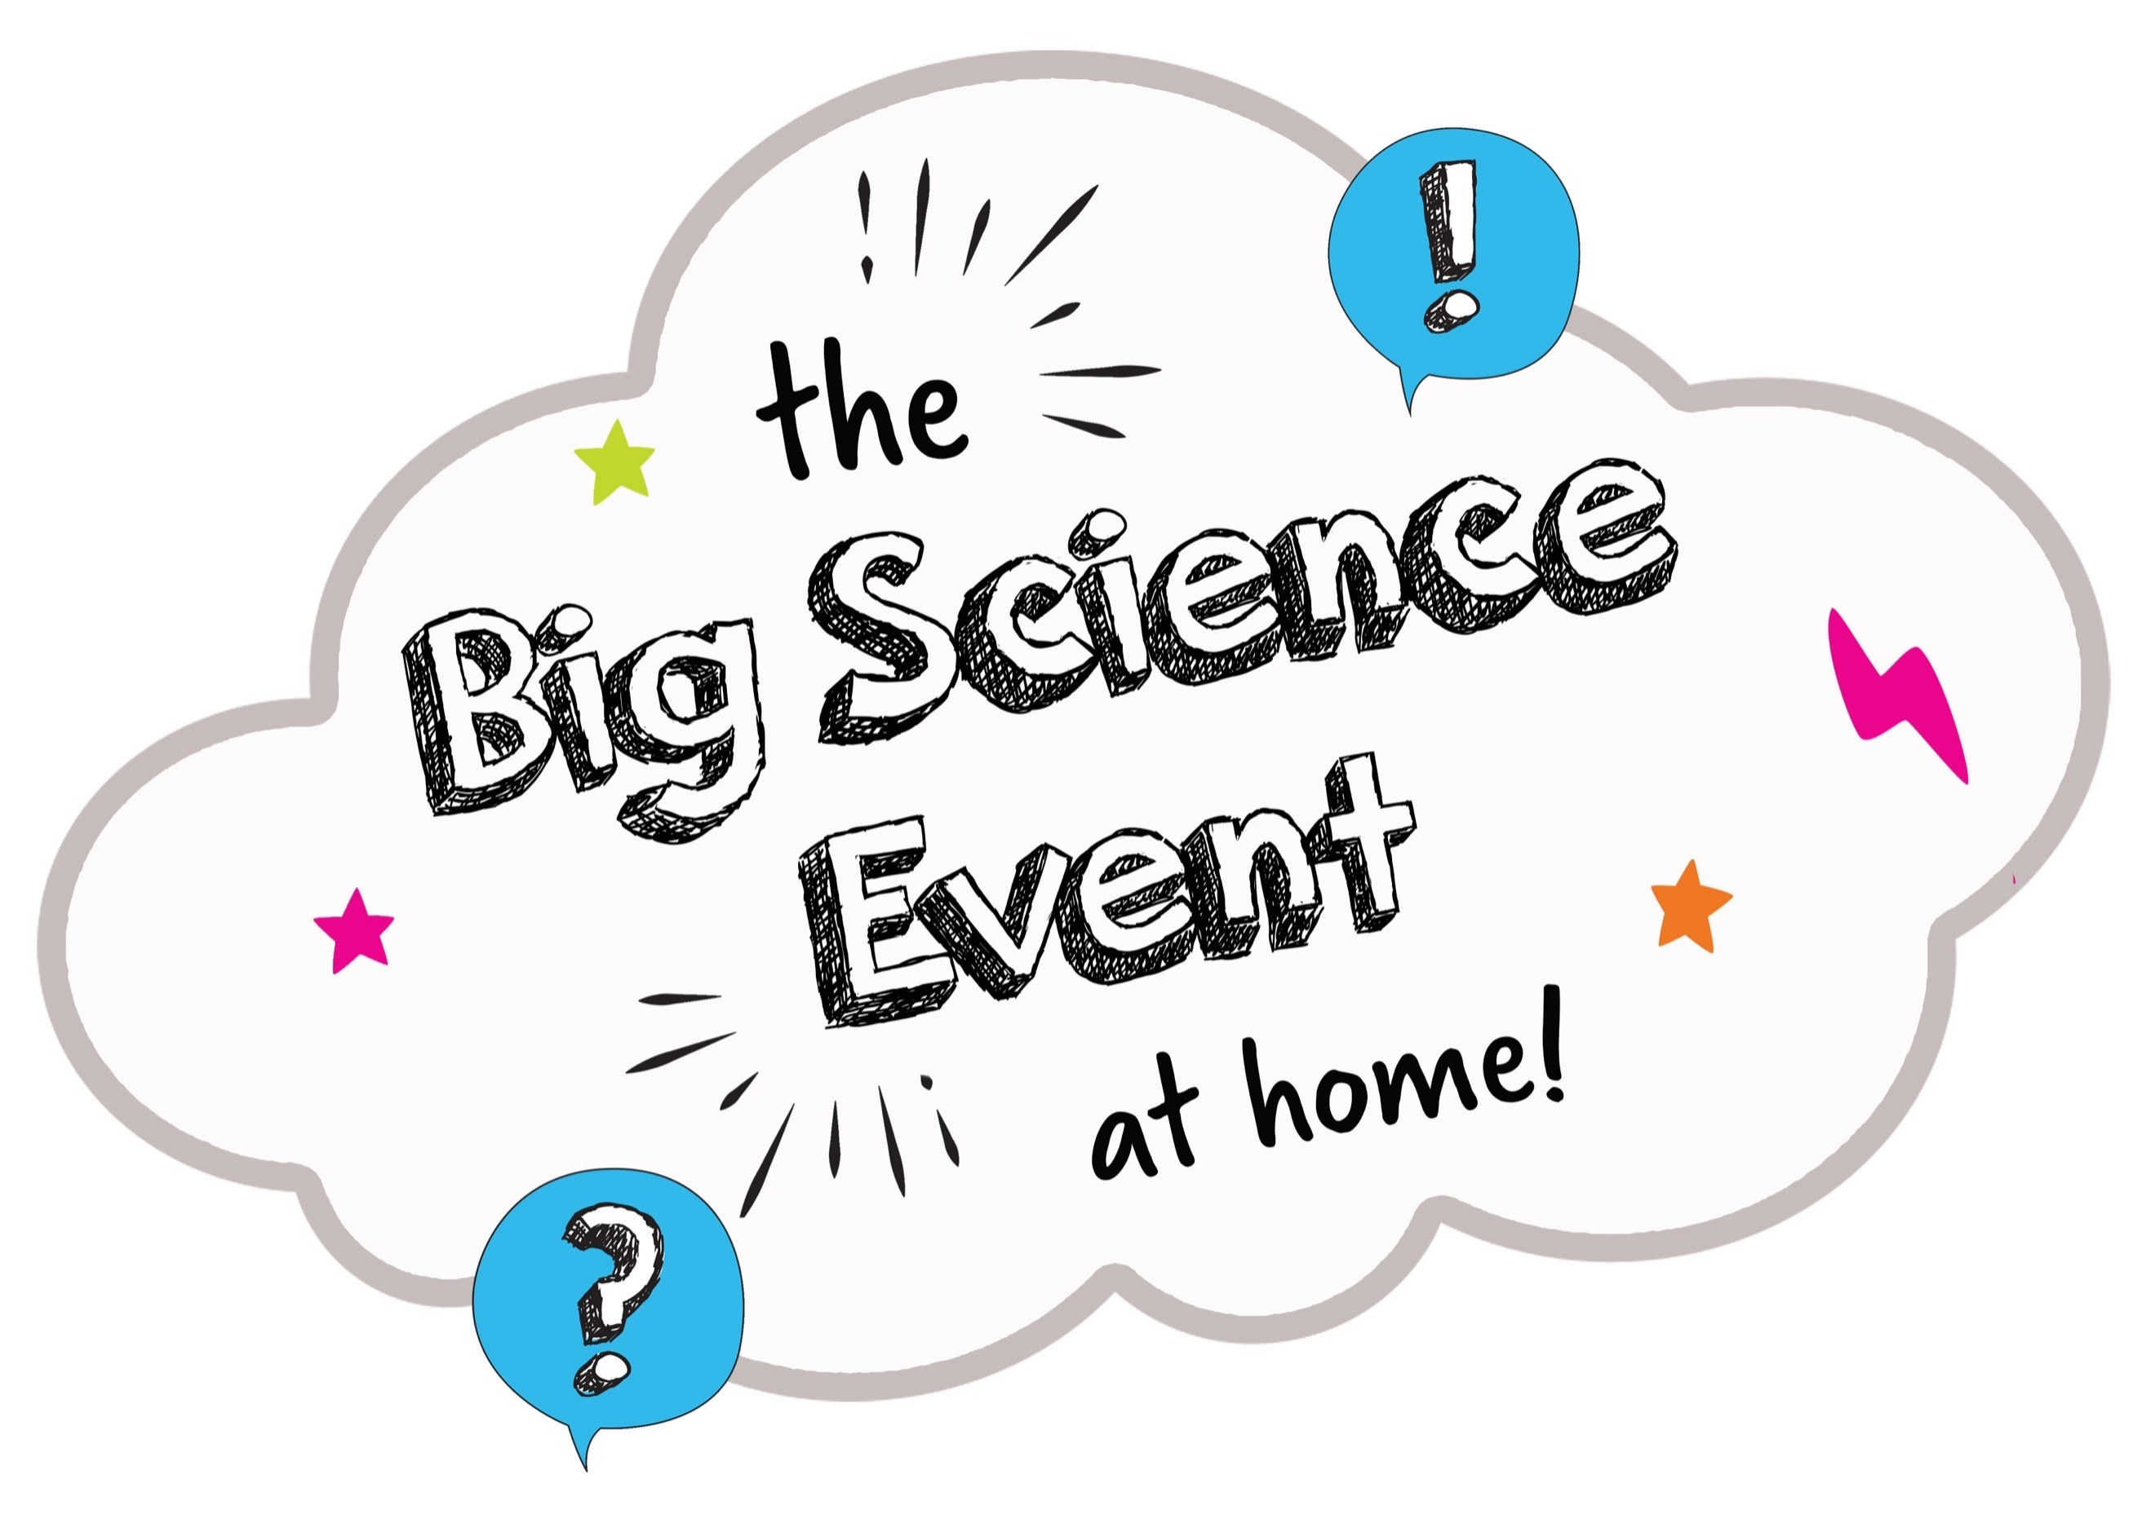

Risk assessment sheet
Please make sure that you talk about your investigation plans with an
adult first. They need to be sure that you have thought about how to
carry out your investigation safely.

Investigation title or question
People in the team | 1.
 | 2.
 | 3.
 | 4.
 | 5.
 | 6.
What might be dangerous? / How could someone get hurt? |  | Who might it be dangerous for? / Who could get hurt? | How will you make it safer?
1.
2.

3.

4.

5.

□ I am happy that the team members have thought about how to carry out their investigation safely.

