Creator/Reviewer of Risk Assessment | Name Bridget Holligan  Science Oxford
 | Signature 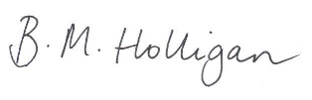
Date | 12.09.18
Severity | Likelihood | Risk Rating* (S x L)
1 No or Little Harm | 1 Unlikely | 1-5 Low
2 Minor/First Aid | 2 Possible | 6-10 Medium
3 Medical Attention | 3 Probable | 10+ high
4 Hospitalisation | 4 Likely
5 Death/Irreparable Injury | 5 Certain

Activity/Item Being Assessed | Hazard Identified | Persons/Property At Risk | Control Measures | Severity | Likelihood | Risk Rating* | Notes/Safety Advice
Maths carousel – table top puzzles & games | One or two games have small items – possible choke hazard | Participants under 3 years | Workshop is advertised for 5-11 years  Workshop is for adults and children together in family groups  Workshop has 3 supervising adults | 3 | 1 | 3

