Try This At Home!
Remember to check with an adult before trying any of our activities and be sure to ask them for help with anything dangerous.
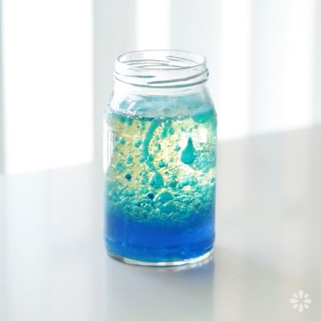
Lava Lamp
You will need:
Tall glass, jar or cup
Vegetable oil
Fizzy vitamin C tablets or alka-seltzer
Food colouring

- Fill the cup ¾ full with oil.
- Add coloured water to a few cms from the top. The oil and water are immiscible (they don’t mix) and the water is more dense, so it sinks to the bottom.
- Drop a fizzy tablet into the cup.

The tablet contains bicarbonate of soda and citric acid which produce carbon dioxide bubbles. The bubbles travel up, pulling some of the coloured water through the oil. When they reach the top, the bubbles pop and the more dense water sinks back through the oil.

Visit www.scienceoxford.com for more experiment ideas and sign up to our newsletter at https://app.sheepcrm.com/f/scienceoxford/privacy/ to make sure you don’t miss out on our fantastic events for families.

