Try This At Home!
Remember to check with an adult before trying any of our activities and be sure to ask them for help with anything dangerous.
Edible ‘Giraffe Poo’
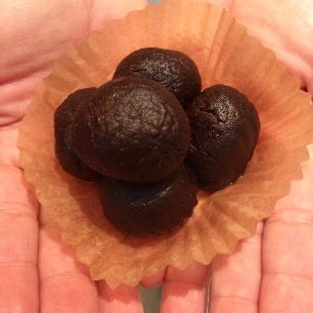
You will need:

250g flour

175g sugar
200g butter
Chocolate chips
85g cocoa

- Mix together all of the dry ingredients.
- Melt the butter and pour over the dry mix.
- Stir well, kneading with hands when the mixture is cool enough.
- The mix should have a truffle like consistency – add more flour if it is too wet and more butter or a splash of milk if it is too dry.
- Shape into small balls (the mixture is very rich!) and pile up into cases to look like giraffe poo. If you’d prefer less sticky treats, roll in icing sugar or cocoa before popping into cases.
- Store in the fridge for up to a week.

Visit www.scienceoxford.com for more experiment ideas and sign up to our newsletter at https://app.sheepcrm.com/f/scienceoxford/privacy/ to make sure you don’t miss out on our fantastic events for families.

