Try This At Home!
Remember to check with an adult before trying any of our activities and be sure to ask them for help with anything dangerous.
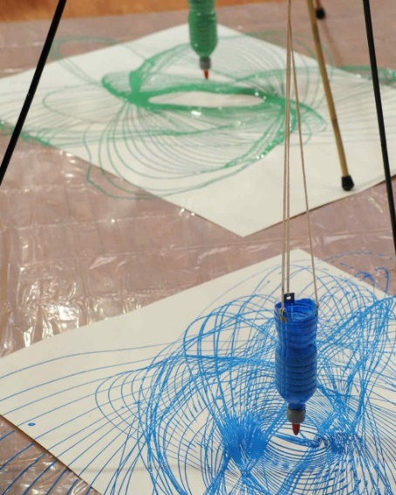
Paint Pendulums
You will need:

3 poles (for tripod)
Cup or bottle
Paint
Water
String
Tape
Paper and pencil

- Create a tripod by lashing together three bamboo poles (or dowels, pipes or similar) with string.
- Puncture a small hole in the bottom of cup or bottle using pencil.
- Tape or tie the cup or bottle to the top of the tripod so it hangs at least 1 cm from the top of the paper when still. Practice swinging it while empty.
- Dilute paint with water in a ratio of 1:1.
- When the cup/bottle is attached and you’ve checked it will swing right, pour the paint in and step away!

Visit www.scienceoxford.com for more experiment ideas and sign up to our newsletter at https://app.sheepcrm.com/f/scienceoxford/privacy/ to make sure you don’t miss out on our fantastic events for families.

