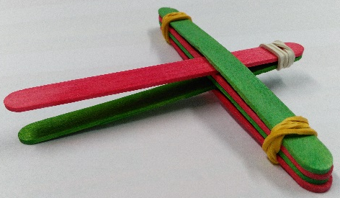

Make a Catapult

Santa has lost his presents! Make the best catapult you can to help get the presents back into his sleigh.

- Take some lolly sticks and rubber bands and construct your catapult using the demo as a guide.

- Test your catapult, does it launch the presents very far?

- What do you think you could do to improve your catapult to send the presents further?

- Try out a new design and test it – can you get the presents back into the sleigh?

The Science

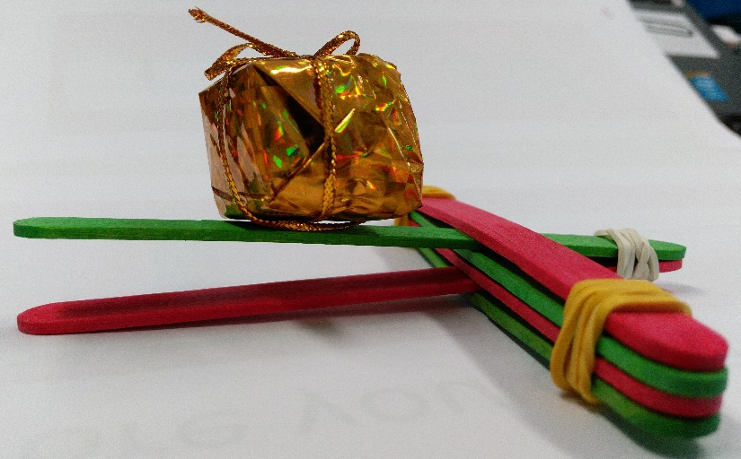
You fire the catapult by pushing on the lolly stick. When you let go, it springs back into position, transferring its energy into the present, causing it to fly!
The bigger the angle, the more energy will be transferred to the presents.

