****

Examples of Previous Big Science Event Entries

Here are some example investigation questions and posters from just some of our favourite previous entries. Whilst we hope these give some useful ideas, we encourage all schools to allow children to develop their own thoughts about what they would like to investigate and come up with their own question!

What materials burn in fire?

Can you make bubbles different colours?

Which liquid affects your teeth the most?

Which size aeroplane goes the furthest?

Which fruit has the strongest outer layer?

Which parachute stays in the air the longest?

Do mirrors always reflect?

What happens to chocolate in different liquids?

Which salt dissolves an ice cube the quickest?

Does the 5 second rule work?

How can we keep flowers fresh for longer?

Which tomato sauce is runniest?

Does the topping affect which way round toast lands?

Which chocolate melts the quickest?

What drink dissolves egg shell the quickest?

Which is the best biscuit to dunk?

Which recipe makes the stretchiest slime?

Can the material used change how a parachute falls?

Which sense is more effective - taste or smell?

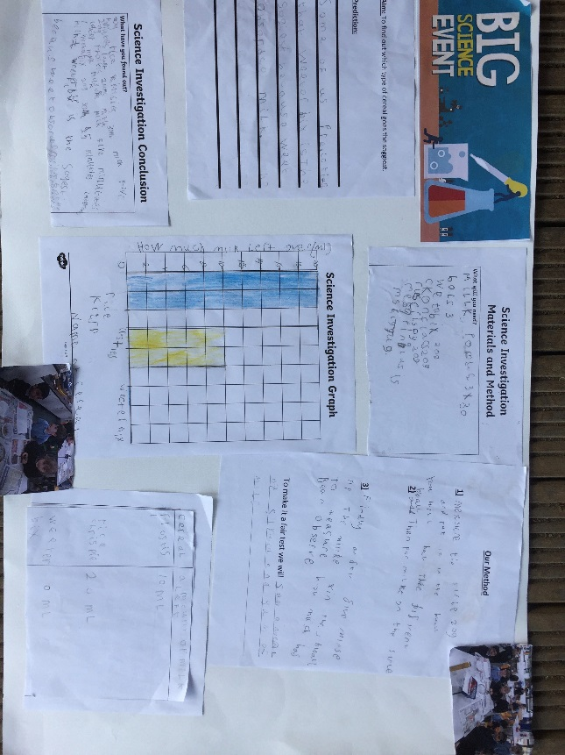Here are some great examples of posters created by children to illustrate their investigations:

